**Kafka Producer-Consumer Messaging in PyCharm**

Step #1: Start Zookeeper Service

Step #2: Start Kafka Server Service

Step #3: Create a PyCharm Project and install kafka-python libraries

Step #4: Create a python file (kafka-producer.py)

Step #5: Create a python file (kafka-consumer.py)

Step #6: Run kafka-consumer.py file

Step #7: Run kafka-producer.py file (If no errors, go to next step)

Step #8: Check the results in consumer results tab

Note: 1. The data is serialized in ASCII format. We can also run the code without serialization.

2. code for .py files is EDITABLE

Code is available in GitHub also- <https://github.com/vanigarikipati/kafka-python-example>

**Step #1: Start Zookeeper Service**

zookeeper-server-start config/zookeeper.properties

**Step #2: Start Kafka Server Service**

kafka-server-start config/server.properties

**Step #3: Create a PyCharm Project and install kafka-python libraries from settings**

**Step #4: Create a python file (kafka-producer.py)**

import json  
  
from kafka import KafkaProducer  
  
BootStrap_Server = "localhost:9092"  
topic_name = "testTopic"  
# message = b'Hello, World testing' # Here Message should be Byte Array if data is NOT Serialized  
message = {"category_id" : 1, "category_department_id" : 2, "category_name" : "Football"}  
# Create a Kafka Producer Object W/O Serialization  
# producer = KafkaProducer(bootstrap_servers=BootStrap_Server)  
  
# Create a Kafka Producer Object W/ Serialization  
producer = KafkaProducer(bootstrap_servers=BootStrap_Server,  
 value_serializer=lambda m: json.dumps(m).encode('ascii'))  
print("Sending Data from Kafka Producer")  
  
# Sending data to Consumer  
producer.send(topic_name, message).get()

**Step #5: Create a python file (kafka-consumer.py)**

from json import loads  
  
from kafka import KafkaConsumer  
  
BootStrap_Server = "localhost:9092"  
topic_name = "testTopic"  
  
# Create Kafka Consumer Object W/O De-Serialization  
# consumer = KafkaConsumer(topic_name, bootstrap_servers=BootStrap_Server)  
  
# Create Kafka Consumer Object W/ De-Serialization  
consumer = KafkaConsumer(topic_name, bootstrap_servers=BootStrap_Server,  
 value_deserializer=lambda m: loads(m.decode('ascii')))  
print("Receiving Data from Producer")  
  
# Display data received from producer  
for message in consumer:  
 print(message.value)

**Step #6: Run kafka-consumer.py file**

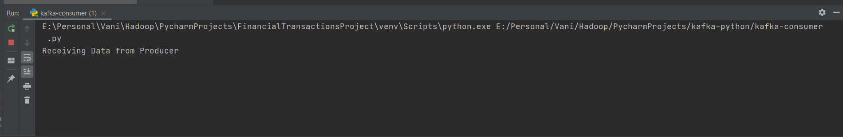

**Step #7: Run kafka-producer.py file (If no errors, go to next step)**

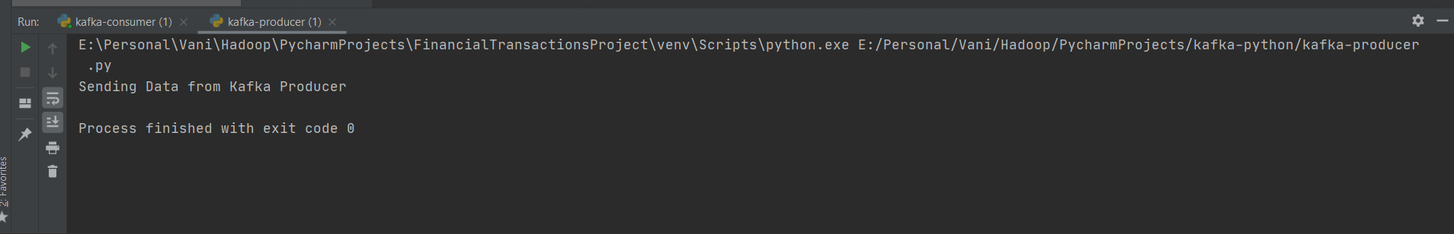

**Step #8: Check the results in consumer results tab**

